***Hello. This is your lecturer Askar Aituov. Copy past this file. Then fill it in and put link to Google docs.***

**Midterm Task 2.1 User research**

Make interviews with 3 users and write their business problem here.

[When] + [action] + result

Example, When I want to post my standup video product, I cannot post it to you tube because it’s banned

We conducted an interview from different 3 users and knew the most common problems they face.

Here are three hypothetical common business problems:

**User 1**: Our group member Aiman’s cousin Aminaa runs a small retail store that sells fashion accessories in her hometown. Her business problem is that she is struggling to keep up with the competition from larger retailers in her area. Aminaa needs to find a way to differentiate her store from other competitors and offer unique products that will attract customers.

**User 2**: Rauan is the owner of a startup that provides digital marketing services to small businesses in huge cities like Astana, Almaty, Shymkent. His business problem is that he is having difficulty acquiring new clients. Rauan needs to find a way to increase his company's visibility and build a strong reputation in the industry to attract new clients.

**User 3**: Ali is the manager of a manufacturing company that produces custom-made furniture. His business problem is that his production process is sometimes inefficient, as a result it leads to delays in fulfilling orders and higher costs. Ali needs to find a way to optimize his production process and reduce costs to improve the profitability of his company.

**Midterm Task 2.2**

***Fill in this table for your product.***

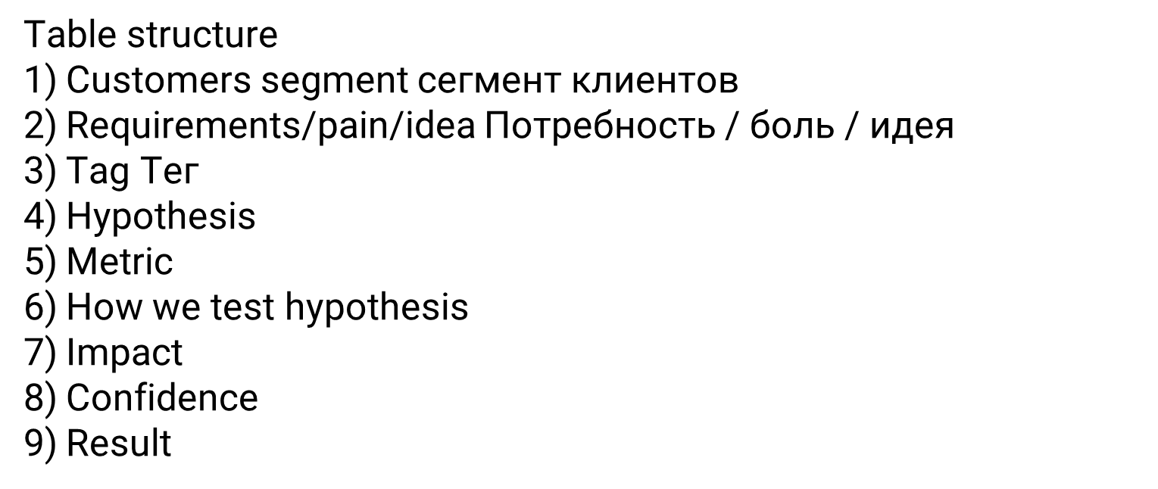

**Midterm Task 1. Competitors Matrix + Map Task template**

***HERE past results of your Task 1.***